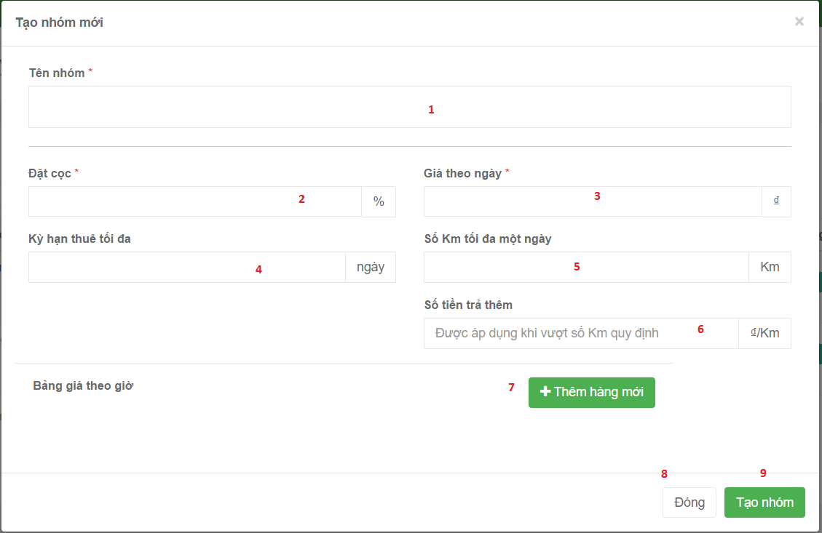

**Fields:**

|  |  |  |  |  |  |  |
| --- | --- | --- | --- | --- | --- | --- |
| No | Field Name | Description | Read Only | Mandatory | Control Type | Data Type |
| 1 | Vehicle group name | Allow user input name of vehicle group | No | Yes | Text box | String |
| 2 | Deposit | Input deposit for booking vehicle | No | Yes | Text box | Number |
| 3 | Price per day | Input money per day | No | Yes | Text Box | Number |
| 4 | Limit time | Input number day for rent vehicle | No | Yes | Text Box | Number |
| 5 | Limit Km | Input number km for rent vehicle | No | Yes | Text Box | Number |
| 6 | Money will pay by over the limit km. | Input money by over the limit km | No | Yes | Text Box | Number |

**Buttons/Hyperlinks:**

|  |  |  |  |  |
| --- | --- | --- | --- | --- |
| No | Function | Description | Validation | Outcome |
| 8 | Cancel add new command | Cancel action add new vehicle group | N/A | Close pop up add new vehicle group |
| 9 | Create new vehicle group | Send create command to controller | N/A | Create new vehicle group. |
| 7 | To add price per hour | Allow user input price per hour. | N/A | Show field allow user input price per hour. |